1.

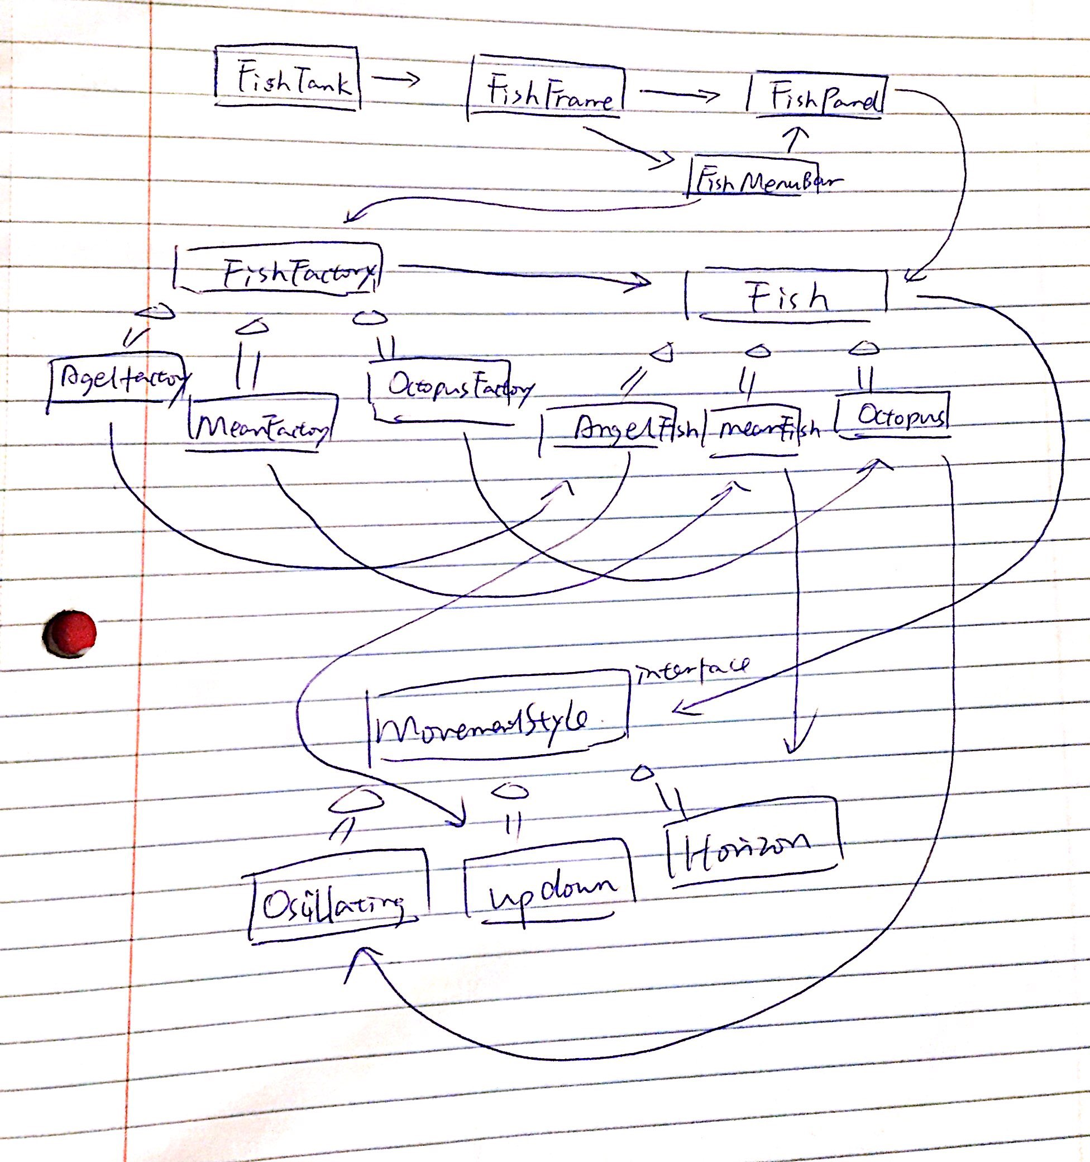

2a. Exclusively view-centric: AgelFish, MeanFish, Octopus, FishPanel, FishFrame, FishTank

2b. Exclusively model-centric: FishFactory, MovementStyle, OctopusFactory, AgelFishFactory, MeanFishFactory, HorizontalMovement, OscillatingMovement, UpDownMovement

2c. Fish: display function is view; move function is model

FishMenuBar: initialization part is view; newFish function is model

3a. FishTankModel keeps track of the different fishes and their movement styles.

3b FishTankView adds certain type of new fish, which is told by the FishTankController, to the panel. It keeps track of the fish’s images.

3c. FTModelObserver should have an update method with a FishTankModel as a parameter. This function is used to get the information from the passed in FishTankModel and then use them to update FishTankView.

3d. FTViewObserver should have an update method with a FishTankView as a parameter. This function is used to get the information from the passed in FishTankView and then use them to update FishTankModel.

3e. It should call getFishType method to get the current status of the view and a setFishType method in order to tell the view what need to be changed.

3f. It should call getMovement method to have the current status of the model and a setMovement method in order to tell the model what need to be changed.

3g. FishTankController should be the action listener. When stop button being pressed, the controller tells both the view and model to stop and update.